CAS PY 106

Prelecture Note 24

1. Adding waves: the principle of superposition
2. 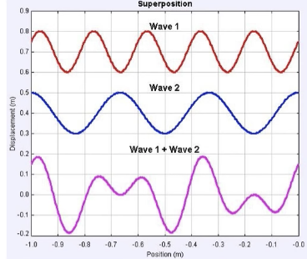
3. When more than one wave is traveling in a medium, the waves simply add
4. The principle of superposition: the net displacement of any point in the medium is the sum of the displacements at that point due to each individual wave
5. Constructive interference
6. 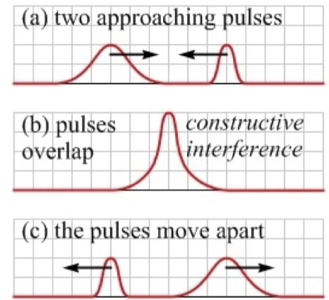
7. When the displacements of individual waves go in the same direction at a point, the result is a large amplitude there, because the displacements add. This is known as constructive interference
8. A neat feature of waves is that after passing through one another, waves travel as if they never met
9. Destructive interference
10. 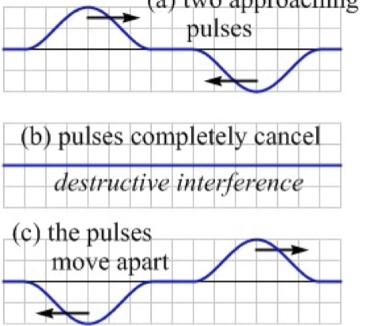
11. When displacements of individual waves are in opposite directions at appoint, the waves cancel (at least partly). This is known as destructive interference
12. How is it possible for the two pulses to re-emerge from the flat string? Where is the energy to do this?

Different parts of the string have lots of kinetic energy

1. Beats
2. When you listen to two sound waves of similar frequency, you hear beats – the intensity of the sound rising and falling
3. When the waves are exactly in phase with another, constructive interference produces a loud sound
4. Waves of different frequencies drift out of phase until completely destructive interference takes place and you hear nothing. The phase difference continues to grow and, closer it gets to a full wavelength shift, the higher the intensity
5. The intensity of the sound oscillates from maximum to zero and back again continually. The closer the waves are in frequency, the slower the cycle of rising and falling intensity. The frequency of the rising and falling is known as the beat frequency, which equals the difference in frequency between the two waves